EVENT CALENDAR
EVENTS IN THE ZELVA DISTRICT FOR 2019
JANUARY

The Christmas ceremony "Shchedriy Vecher"
Zelva, central square
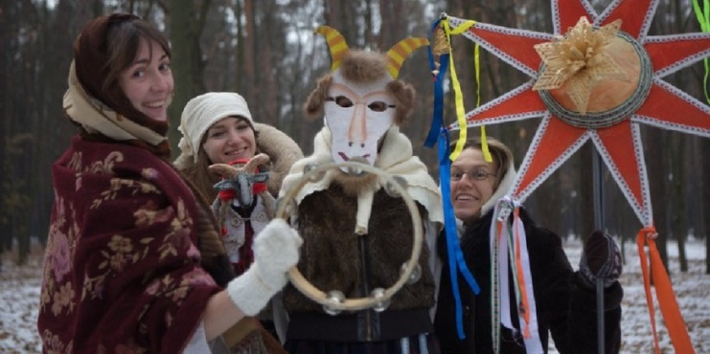
The inhabitants and guests of Zelva can feel the atmosphere of the most wonderful and magical winter holiday Christmas during the ceremony "Shchedriy Vecher". The program includes a theatrical performance "Ehala Kalyada from end to end...", an entertainment program "Kalyadniya Perazovy", as well as a concert program "Kalyadnye zorak svet nyabesny" with the participation of the best collectives and performers of Zelva. You will hear the songs that bring fun and overcome the evil. You will also taste holiday treats, take part in games and contests.
Tel.: +375(1564) 71002, +375(1564)24531 (08.30-17.30 )
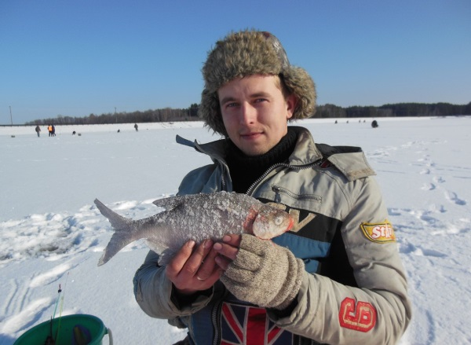
“Zelva Ice-2019”- fishing with a winter fish-rod
Zelva, Zelva artificial water reservoir, Grodno region
As soon as a real winter comes to Zelva,a fishing contest “Zelva Ice” gathers together those who love fithing . The competition is an uncormercial project in wich fishers-sportsmen from the whole Belarus can take part. The aim of the project is to claim healthy way of life and make sports fishing popular in Belarus.
Depending on the results all of the fishers are devided into two groups (A and B) and are placed into certain definite sectors. The winners of the competitions are chosen both among the teams and in personal records.
Tel.number : +375156423094
Natalia (Alexandrovna) Gospodarik
FEBRUARY

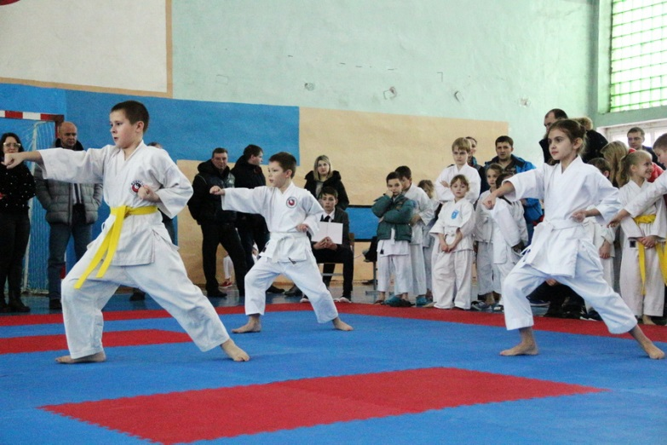
Open regional competitions in shotokan karate-do “Winter -2019”, Zelva, Grodno region
Introduction of the norms of healthy lifestyle, development of cultural and sports ties between all the regions of the Republic of Belarus, popularization of shotokan karate –do trainings in Zelva district and in Grodno region- these are the main aims of Open regional competitions in shotokan karate-do. At the same time it’s a perfect chance to improve proficiency of all the participants of the competitions: sportsmen, referees and trainers.
Tel.: +375293119517
Vladimir (Ivanovich) Lameko
MARCH
The regional holiday "Maslennitsa"
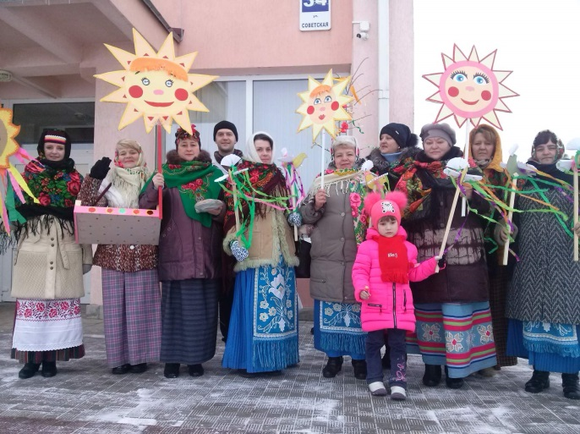
Zelva, the central square
The element of this holiday is burning of a stuffed person. You can taste pancakes and skate with slides. Competitions, folk games and attractions, an exhibition of works by folk craftsmen, performance of the best collectives of the district will be prepared for the guests. At the end of the performance is the traditional rite - burning of a stuffed person of winter.
Tel.: +375(1564) 71002, +375 (1564) 24531 (08.30-17.30 h)
MAY
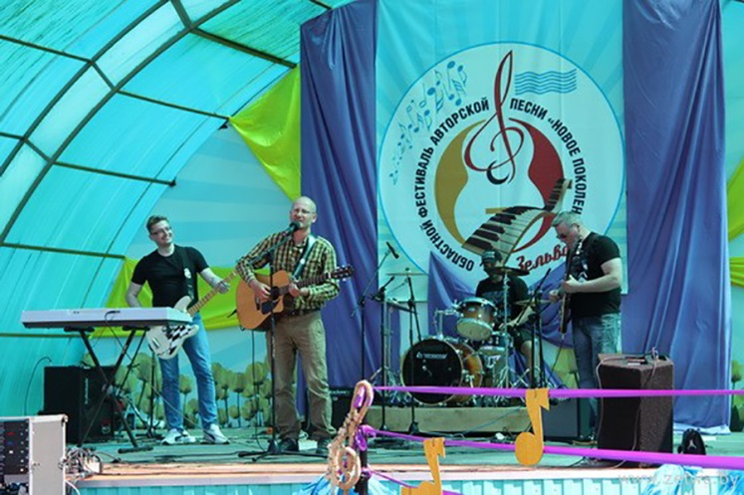
Regional author song festival "New Generation"
Zelva, summer stage
Zelva invites all fans of good music and live performance to attend the annual regional festival-contest of the author's song "New Generation". Talented authors of poems and the composers at the age of 18 to 35 will present their work to the public. The guests of the holiday will listen to poems, touching melodies, brilliant concert performances, as well as a great number of impressions and positive emotions.
Tel.: +375(1564)71002, +375(1564)24531 (08.30-17.30)

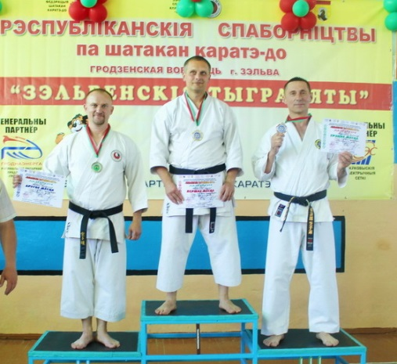
The 10th Republican competitions in Shotokan Karate-Do “Tiger Cubs of Zelva”, Zelva,
Grodno region
Every year Zelva hosts participants of the republican competitions “Tiger Cubs of Zelva ”. The tournament begins with sections in kohai-programme (kihon).
Republican categories of the competition take place on the second day of the project “Tiger Cubs of Zelva”.
According to the results of the competition a National team of the Republic of Belarus is formed for taking participation in the Cup of Europe among the clubs/ federations in shotokan karate-do.
Tel. number: +375293119517
Vladimir (Ivanovich) Lameko

Holiday milk «Milk river»
AG. Krivichi
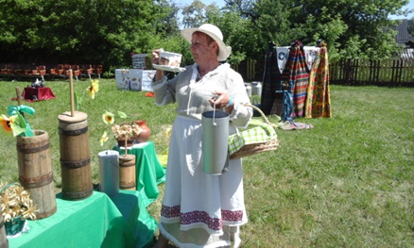
Holiday milk "Milk river" in ar. Civic day is timed to coincide with the day of Western milk (world milk day), which is traditionally celebrated on June 1.
Everyone will be able to try cheese, homemade yogurt, a drink for forty and delicious pastries from RG digestion platform milk products, visit the photo exhibition "Recognize me mistress", a book exhibition about Pets.
The event will host the path of the best owners for the delivery of milk in the ninth: "the greatest number of Dan liters of milk", "the highest star of milk", "the highest luck on one crust", the victory will be awarded the diploma and cash premium.
For children there is a Playground, where the port is on the mountain LP, in the contest to participate in the risk, on the background of the photographers of the "tractor scene" and Rostov – cycle.
Holiday concerts fun songs and dances.
Tel.: +375(1564) 71002, +375(1564) 24531 (08.30-17.30)

JUNE
Праздник народных ремёсел «Ремесло как образ жизни»
Festival of folk crafts " Craft as a way of life»
AG. Derechin
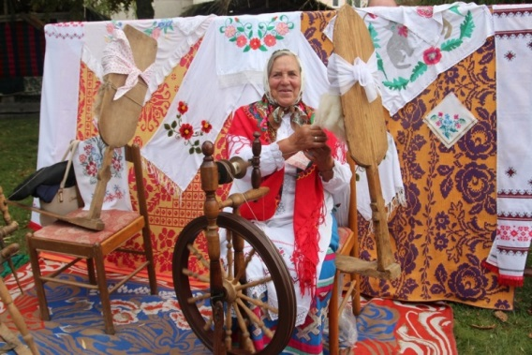
Fans of traditional crafts in the early summer is to visit the large-scale holiday AG. Derechin - "Craft as a way of life". On this day the centre of an agro-town will turn into a large exhibition of handmade beauty, made of vines, wood, clay, metal, paper, etc. Everyone will be able to work the Potter's wheel or a loom, to embroider a beautiful napkin or a straw to make a souvenir. Guests of the event"Craft as a way of life" will find exciting thematic workshops, humorous theatrical performances and diverse concert program with Amateur art groups. "Craft as a way of life" is a celebration for the owners of good taste, true connoisseurs of art and devoted fans of national traditions.
Tel.: +375(1564) 71002, +375(1564) 24531 (08.30-17.30)

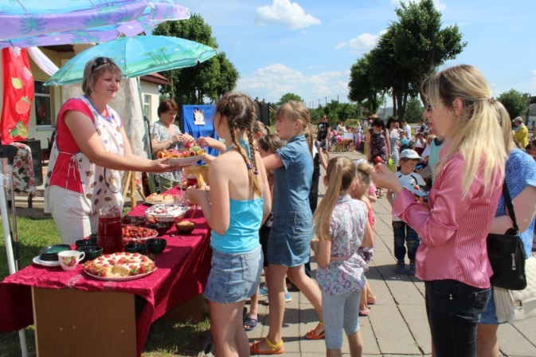
A strawberry-scented holiday, AG. Borodichi
The words "strawberry" and "Borodachi" for more than a quarter of a century, there are as synonymous- words, for it grows almost every.
Residents and guests of the agricultural town on this day waiting for fun adventures in the "Strawberry Kingdom". Queen Strawberry will meet guests with songs, drinks and strawberries of different types and varieties, fresh pastries with delicate strawberry filling, which will conquer all the sweet tooth. Everyone will be able to participate in games, contests, quizzes, make a souvenir on berry theme, participate in the drawing contest.
At the festival, experienced Housewives will hold master classes on cooking strawberry fondue and jam. A "strawberry" manicure will conquer all fashionistas the holiday.
Tel.: +375(1564) 71002, +375 (1564) 24531 (08.30-17.30)

“The Cup of the Western region -2019” in sports fishing, Zelva
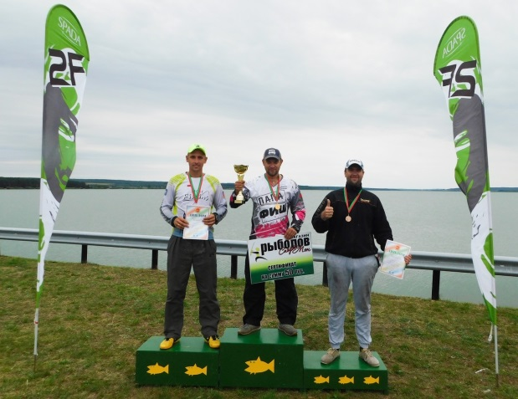
The best sportsmen from all the regions of Belarus come to Zelva to meet at the shores of its artificial lake.
According to the toss-up ( sortition) all of the sportsmen are devided into two groups (A and B) and are placed into the strictly specified sectors on the right and on the left sides of the dam. Referees control if the participants in each of the sectors observe the rules of the competition. The process of fishing lasts for 5 hours during each of these two days. The winners of the contest are honoured both in team and personal nominations. The whole sums of the points which are gained by the teams during these two days and the weight of the fish, that have been caught, are taken into consideration when summing-up.
Tel.number: +375156423094
Natalia (Alexandrovna) Gospodarik

Folklore festival "Chime of Talents"
Karolin, Zelvensky district
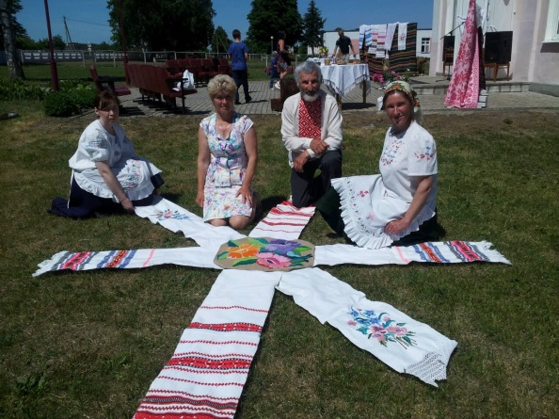
Folklore festival "Chime of talents" will bring together all lovers of folk art in Carolyn, which is held with the aim of reviving and preserving local folklore, folk art; familiarizing the younger generation with the traditions of the Belarusian.
Songs, dances and folk legends will help to feel the atmosphere of festive mood. Guests will find a variety of games, contests, a concert program, fascinating master classes, the opportunity to buy souvenirs at the exhibition-sale of products by masters of folk art.
Tel.: +375(1564)71002, +375(1564)24531 (08.30-17.30)
The festival of youth creativity "Maladziozhnaya praising»
G. p. Zelva
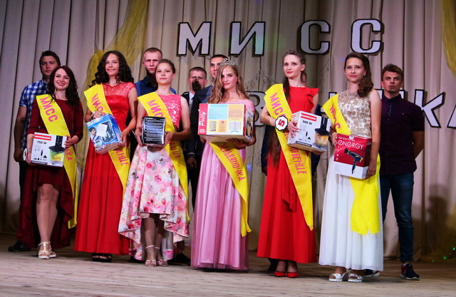
Traditionally, as part of the youth Day in the city of Zelva is a festival of creativity of young people – a real celebration of beauty, vivid impressions, performances of young singers and musicians. For the title of "Miss Zelva" will fight amazing girls, harmoniously combining the visual appeal and femininity with brilliant intelligence and determination. The winner will be the most successful and talented.
The festival will end with a enchanting beach disco.
Tel.: +375 (1564) 71002, +375 (1564) 24531 (08.30-17.30)

JULY
The regional holiday "Kupalie"
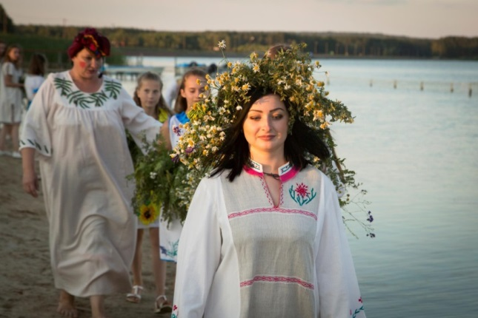
Zelva, the coast of the reservoir
"Kupalie" is a theatrical folk holiday with traditional ritual elements. The guests of the event will meet with the characters of this fabulous night. Everyone will be able to take part in round dances and folk games. You can also tell fortune on wreaths and jump over the fire. Original music will sound at the festival. The adventurers will go to look for a blossoming fern. And they will certainly find their mascot of luck!
Tel.: +375(1564)71002, +375(1564)24531 (08.30-17.30)
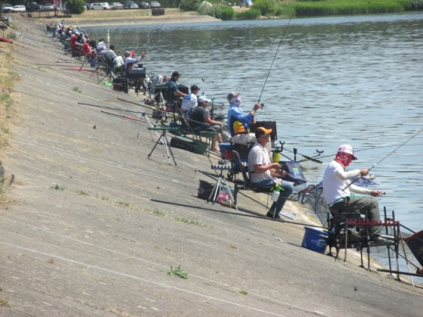
Tournament “National fishing – 2019” in fishing with a summer fish-rod
Zelva, Zelva artificial water reservoir
Every year Zelva becomes the place of meeting for hundreds of people connected by a common hobby- fishing. Both proffessionals and amateurs may take part in the contest.
The main feature of national fishing is absence of strict regulations to fishing tackle. Everyone can fish as with a feeder so with a summer one-hooked fish-rod.
Fishers may choose the type and quantity of the lure and the bait. The place where the fisher will spend three hours catching fish is decided according to the drawing.
Fishers have possibility to compete in personal record, to exchange their own experience, to meet friends and amateurs of fishing. The main task is to catch as much fish as possible. In personal record the one who will catch the largest fish wins.
Tel.number: +375146423094
Natalia (Alexandrovna) Gospodarik

AUGUST

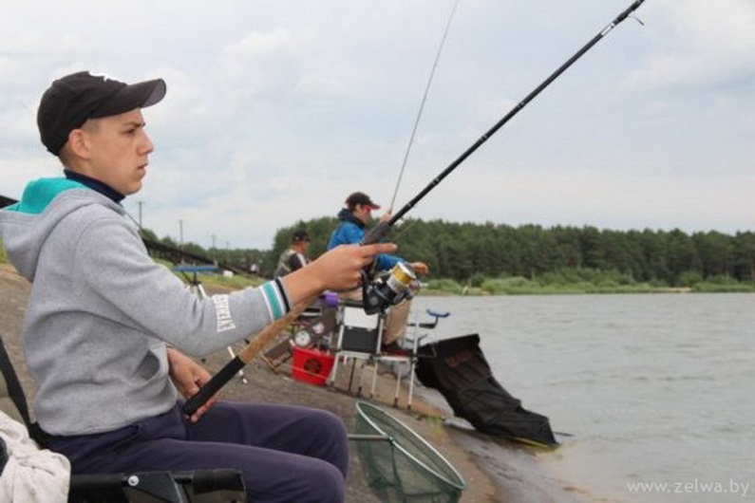
“Championship of Grodno region in fishing with a summer fishing-rod among students – 2019”
Zelva, Zelva artificial water reservoir
Teams of students- amateurs of fishing gather at the enbankment of the lake. Young fishers have a chance to compete in fishing in personal record, to exchange their own experience, to meet friends, to make new ones, to get help from their more experienced collegues. The main aim is introductory of culture of fishing and popularization of sports fishing among students.
According to the rules of the competition young fishers can use either a float fish-rod or a feeder fish-rod with one hook only.
All the fish that will be caught during the competition will be returned to the lake after weighing.
Tel.number: +375156423094
Natalia (Alexandrovna) Gospodarik

The regional holiday "Annensky Kirmash"
Zelva
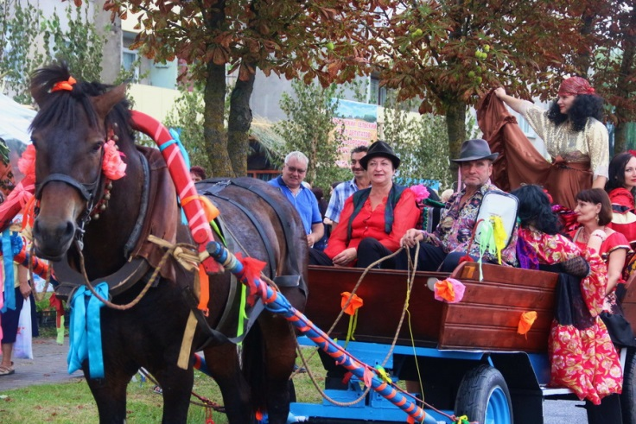
A unique cultural event will be at the end of August in Zelva. It’s the traditional local holiday - "Annensky Kirmash". This holiday is connected with the day of St. Ann. The idea to celebrate the fair was originated in the 18th century, when merchants and artisans from all over the Polish-Lithuanian Commonwealth and European countries gathered in Zelva. This year many original contests will be held within the framework of the event. At the end of the event the winners will be selected in the following nominations: "The best balcony design", "The best stylized costume", "The best photos and video of the holiday", "The most delicious loaf", "The most colourful courtyard ", "The most beautiful horse carriage", etc. The bright accent of the festive program is the presentation of agro-fairs, medium and small businesses sites. Everyone will be able to buy original souvenirs at the exhibition-fair of decorative and applied arts. The collectives of amateur creativity and famous singers will delight the audience with brilliant concerts.
Tel.: +375(1564) 71002, +375(1564) 24531 (08.30-17.30)

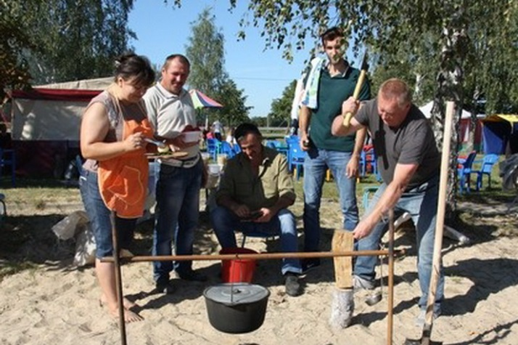
“Championship of Zelva region in fishing with a summer rode and in cooking fish-soup (uha) - 2019”
Zelva, Zelva artificial water reservoir
Amateurs of fishing gather in Zelva, at the embankment of the lake. The main aims are not only to find the best fishermen, but also to develop and popularize sports fishing as one of the forms of active rest.
Sportsmen catch fish standing on the shore. They can use just one fish-rod with one single fish-hook. Quantity of additional fishing tackle isn’t restricted. Participants of the competition can use only swing gear with a cork float.
A competition for the best fish-soup (uha) also takes place. Everyone may taste fish-soup.
Tel.number: +375156423094
Natalia (Alexandrovna) Gospodarik

SEPTEMBER
Holiday potatoes.
AG. Knyazevo
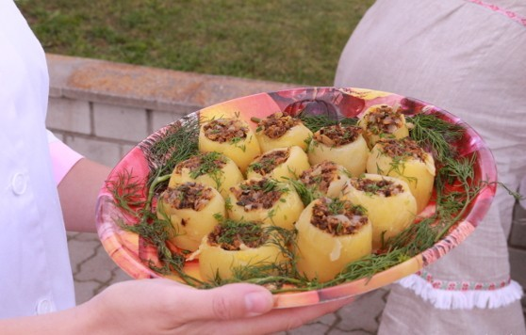
Autumn AG. Knyazevo is waiting for all connoisseurs of the "second bread" of Belarusians at the potato festival.
The program includes an exhibition and sale of industrial and food products, sporting events, a cheerful concert, an exhibition of products by masters of folk art and an incendiary potato party with good music and dancing until you drop!
Everyone will be able to show skill and ingenuity in a variety of contests and games, will learn a lot about the ways of planting potatoes, will take part in culinary master classes.
Guests of the festival will have an opportunity to appreciate the taste of traditional dishes of Belarusian cuisine.
Tel.: +375(1564) 71002, +375(1564) 24531 (08.30-17.30)

DECEMBER

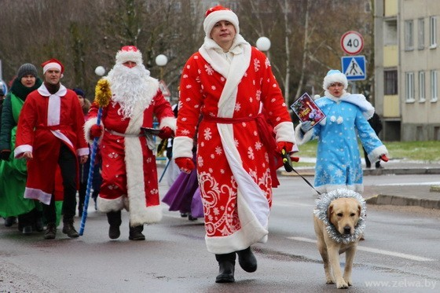
Carnival procession of Fathers the Frost and Snow Maidens
Zelva, central square
New Year's atmosphere in Zelva will be before the clock chime. On the eve of the main winter holiday the residents and the guests of the town will see a great parade with the participation of the kind Fathers the Frost and the most charming Snow Maidens. A snowman, a young New Year, fairy-tale characters with singing and dancing will please children and adults. All participants of the holiday will be given many congratulations, jokes, riddles, songs, dances and treats.
Tel.: +375(1564)71002, +375(1564) 24531 (08: 30-17: 30)
http://zcknt.zelva-kultura.by

